**Lab – #9 CREATING TABLES (40 points)**

**DUE BY THE START OF CLASS ON MARCH 31st 2016**

**INSTRUCTIONS:** Using the logical model below, create the four tables and all of the listed columns within each table. You are also required to create the PRIMARY KEY and NOT NULL CONSTRAINTS on the tables and columns and proper datatypes for each column. As the lead DB developer/implementer, it is up to you to decide the proper length of each datatype; however, if you create a length that doesn’t make obvious sense, I will mark it incorrect (e.g., having ‘customer name’ with a length of 10 characters).

**DELIVERABLE:** You will submit a flat-file text document in D2L for Lab #9 with each of the four sections that are a part of this lab. For example, for STEP #1, you should have four SQL statements showing me the SQL syntax you used to CREATE your tables. For STEP #2 I will be looking into your tables to see the inserted data. You must use the SQL Developer IMPORT feature (I can tell if you did or didn’t). For STEP #3 I need to see your SQL statements for each of the seven questions. Lastly for STEP #4, I need to see your SQL statement for question #1 (adding a new column) and question #2 (truncating table data). Follow the specific instructions for question #3 and I will be checking your table structure to see if you completed the tasks

**STEP #1 – CREATE TABLES, COLUMNS, CONSTRAINTS (21 points)  
(every column of every table is mandatory…remember the PK doesn’t require a NN constraint)**

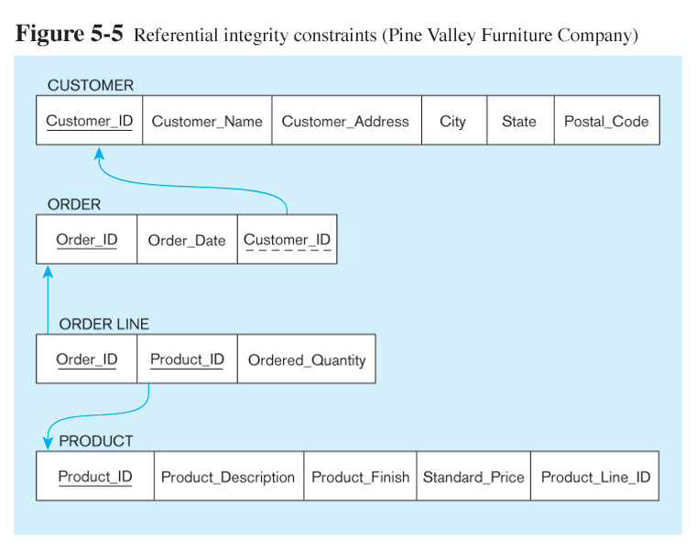

**STEP #2 – INSERT DATA FROM FILE (8 points)**

Using the Excel file called “Lab#9-RawData” located in the Lab #9 content area, import data for each of the tables you created. Each set of table data is separated into separate worksheets shown at the bottom of the Excel workbook.

**STEP #3 – QUERY THE DATABASE (7 points)**

1. Show product id and finish for all products

2. Show product id and finish for all products, sort by product_line_id by ascending order

3. Show product id and finish for all products, sort by product_line_id by descending order

4. Show each product_line_id and the total number of products for the product_line_id

5. Show product_id and description for all products whose names contain a string of "Table"

6. Change a product_description from 'Duplex Table Lamp' to 'Arch Table Lamp'

7. Show dates and how many orders received in each individual day

**STEP #4 - CREATE NEW COLUMN IN TABLE (4 points)**

1. Add a new column to the CUSTOMER table called ‘Region’ and assign the datatype as varchar2(20) and make it a mandatory field.

***You should receive an error when you try to add this column****

2. Truncate all data from the CUSTOMER table and re-run the SQL command to add a new column from problem #9.

3. Open up the “Lab#9-RawData” spreadsheet and add “REGION” in cell G1 in the spreadsheet. In cells G2 through G5 type “North America”. Save the spread sheet and re-import the data from the CUSTOMER worksheet back into your CUSTOMER table in Oracle.